Name:Motasim Mohamed Abdelmageed

B.N:948

2021/6/5Date:

Topic:Programing Languages

# Screenshots

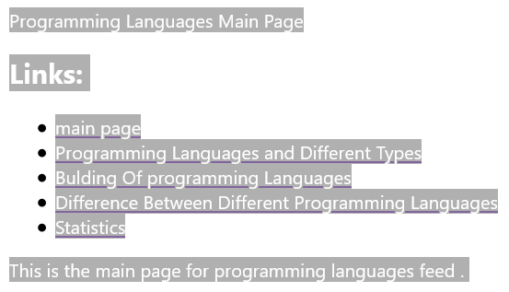

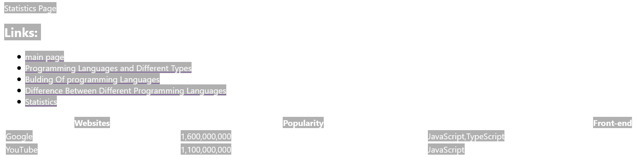

# Source Code:

